CS 611 Final Project
Team 31
XinLong Zhang: part of object classes, operations related to Database

Yuesi Liu: part of object classes, debugs

Zhaoyu Yin: manage the structure and GUIs
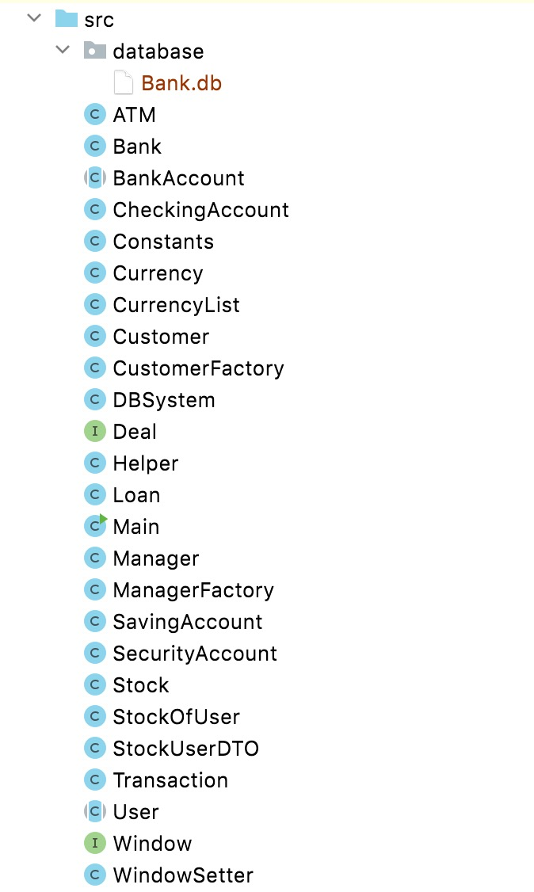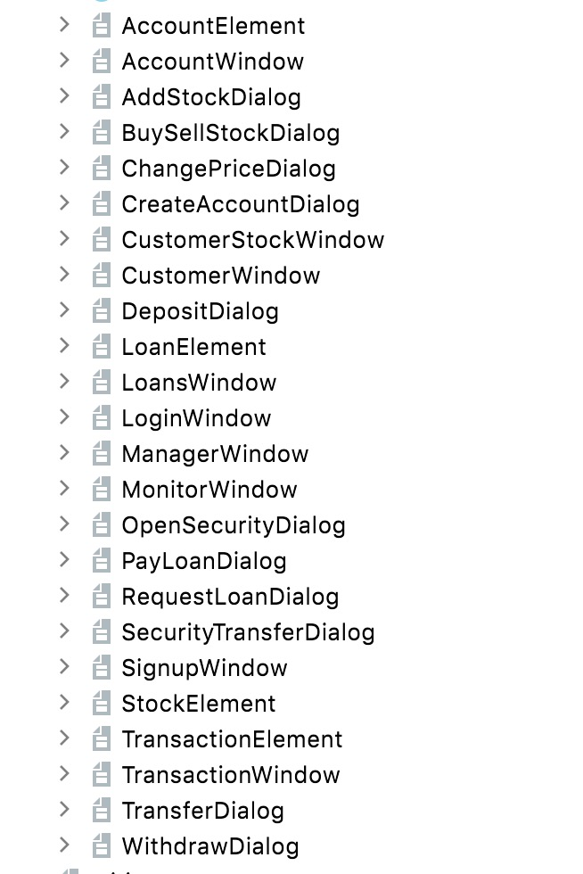

GUI Relationship:
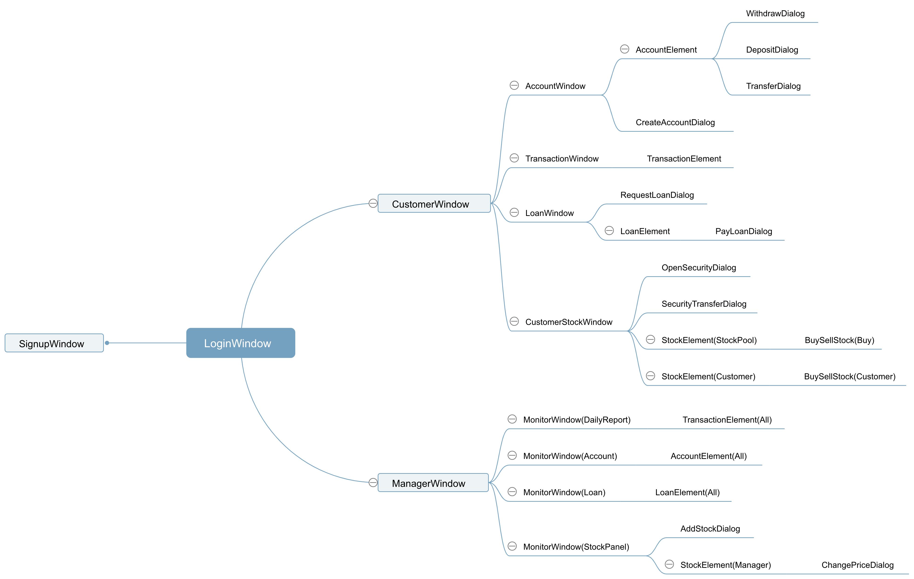

Class Implementation:
- Description of ood classes:

ATM.java: A ATM object. It serves as a bridge between Database and GUI. It handle data passed in by GUI and send it to database
for verification/action then pass the verification result/action result back to GUI.

Bank.java:A Bank object where has a Bank Database.

BankAccount.java:A BankAccount object. It is super class of CheckingAccount,SavingAccount and SecurityAccount. It stores basic
information of a bank account.

CheckingAccount.java: A CheckingAccount object. It is the subclass of BankAccount.

Constants.java:A Constants object. It keeps all the constant static variables in the program.

Currency.java:A Currency object. It keeps track of exchange rate and currency code of a single currency.

CurrencyList.java: A CurrencyList object. It keeps all the currency codes and exchange rates.

Customer.java:A Customer object. It is a subclass of User class. Customer has multiple bank accounts.

CustomerFactory.java: A CustomerFactory object. It encapsulate the creation of Customer.

Deal.java: A Deal object.

Helper.java:A Helper object. It helps with the execution of the program.

Loan.java:A Loan object. It contains specific details on a single Loan.

Main.java:A Main object. It starts the whole program.

Manager.java:A Manager object. It is a subclass of User class. The Manager can apply interest on both loans and deposits.

ManagerFactory.java: A ManagerFactory object. It encapsulates the creation of Manager.

SavingAccount.java: A SavingAccount object. It is a subclass of BankAccount class.

SecurityAccount.java: A SecurityAccount object. Users can create an security account when they have enough balance in their
account.

Stock.java: A Stock object. It contains all the info about a specific stock.

StockOfUser.java: A StockOfUser object. It contains info for all the stocks that a user has bought.

Transaction.java: A Transaction object. It contains all the info about a specific transaction.

User.java: A User object. It is the super class of Manager and Customer class. It contains basic info about a user.

Window.java: A Window object.

WindowsSetter.java: A WindowSetter object. It contains helper functions for windows setting.

- Description of GUI classes:

AccountElement File: AccountElement File contains AccountElement class and form. It genreates a window for users to deposit/withdraw/transfer.

AccountWindow File: AccountWindow File contains AccountWindow class and form. It generates a window to create accounts.

AddStockDialog File: AddStockDialog File contains AddStockDialog class and form. It prompts users a window to add stock.

BuySellStockDialog File: BuySellStockDialog File contains BuySellStockDialog class and form. It prompts users a window to buy and sell stocks.

ChangePriceDialog File: ChangePriceDialog File contains ChangePriceDialog class and form.
It prompts manager a window to change the stock's price.

CreateAccountDialog File: CreateAccountDialog File contains CreateAccountDialog class and form. It prompts an window for users
to choose the type of account and balance they want to setup.

CustomerStockWindow File: CustomerStockWindow File contains CustomerStockWindow class and form. It prompts a window for users to view the details of their secuirtyaccount including
the stock pool.

CustomerWindow File:CustomerWindow File contains CustomerWindow class and form. It prompts a window for users to choose the desired
information they want. Information contains Account, Transaction, Stock, Loan.

DepositDialog File:DepositDialog File contains DepositDialog class and form. It prompts a window for users to enter the
amount of deposit.

LoanElement File:LoanElement File contains LoanElement class and form. It prompts a window to direct customers to pay their loan. In the case of a manager, the window prompts the info regarding collateral, currency, amount and userid.

LoansWindow File: LoansWindow File contains LoansWindow class and form. It prompts a window which has a request loan button and the rules for requesting a loan.

LoginWindow File: LoginWindow File contains LoginWindow class nad form. It prompts a window for both customers and managers to login.

ManagerWindow File: ManagerWindow File contains ManagerWindow class and form. It prompts detailed information of all the users to
the manager.

MonitorWindow File: MonitorWindow File contains MonitorWindow class and form. It prompts detailed information of Daily report/
account/loans

OpenSecurityDialog File: OpenSecurityDialog File contains OpenSecurityDialog class and form. It prompts users a window to open a security account.

PayLoanDialog File: PayLoanDialog File contains PayLoanDialog class and form. It prompts a window for users to enter the amount of
loan they pay.

RequestLoanDialog File: RequestLoanDialog File contains RequestLoanDialog class and form. It prompts a window for users to take
out loan.

SecurityTransferDialog File: SecurityTransferDialog File contains SecurityTransferDialog class and form. It prompts users a window to transfer money from saving to security or vice versa.

SignupWindow File: SignupWindow File contains SignupWindow class and form. It prompts a window for users to sign up an account in
the bank.

StockElement File: StockElement File contains StockElement class and form. It prompts a window for users to see the info of the stocks.

TransactionElement File:TransactionElement File contains TransactionElement class and form. It prompts a window for users to check details of a transaction.

TransactionWindow File: TransactionWindow File contains TransactionWindow class and form. It prompts a window for users to start
a transaction.

TransferDialog File: TransferDialog File contains TransferDialog class and form. It prompts a window for users to transfer money
to a specific account.

WithdrawDialog File: WithdrawDialog File contains WithdrawDialog class and form. It prompts a window for users to enter the amount
they want to withdraw.

- Description of Database classes

DBSystem.java: A DBSystem object. It provides database support for the ATM program. Any changes made by users are reflected on the database.
Therefore, everything is traceable and well recorded for ATM project.

StockUserDTO.java: A StockUserDTO object. It contains specific info for a stock which a user has bought.

UML Diagram：
